Scenario 1: Web Service based integration through SOAPUI for DFA

We are making some Change at DFA amount level as below:

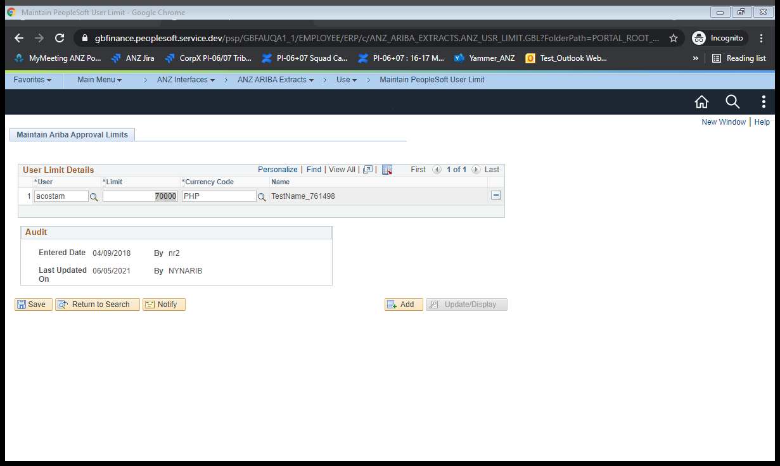

Go with Employee “acostam” to make changes of DFA amount as “70000”

Click on Save Button

Navigate to the below path:

Main Menu🡪People Tools🡪Integration Broker🡪Integration Setup🡪Service

Search for the “ANZ_GET_DFAINC_DETAIL” service as below:

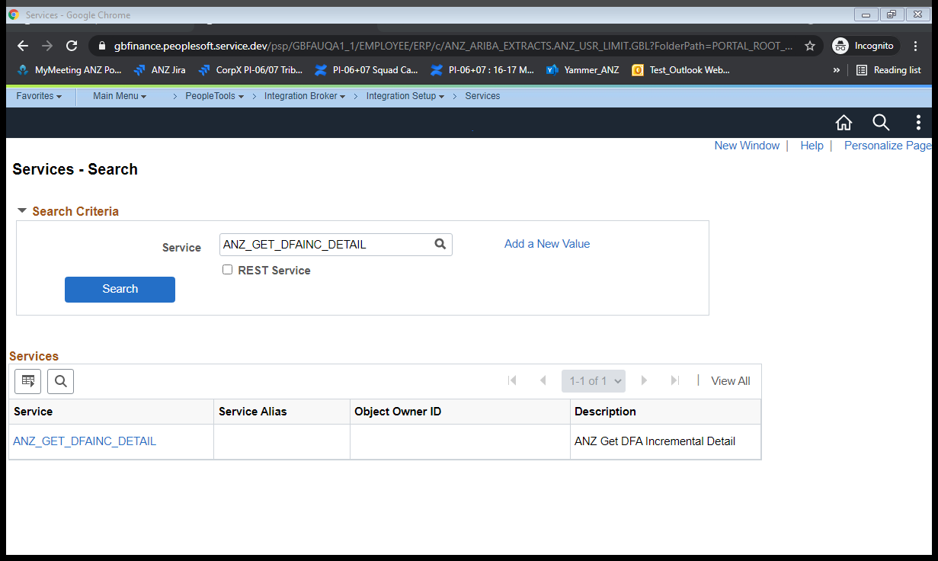

Click on Service Hyperlink

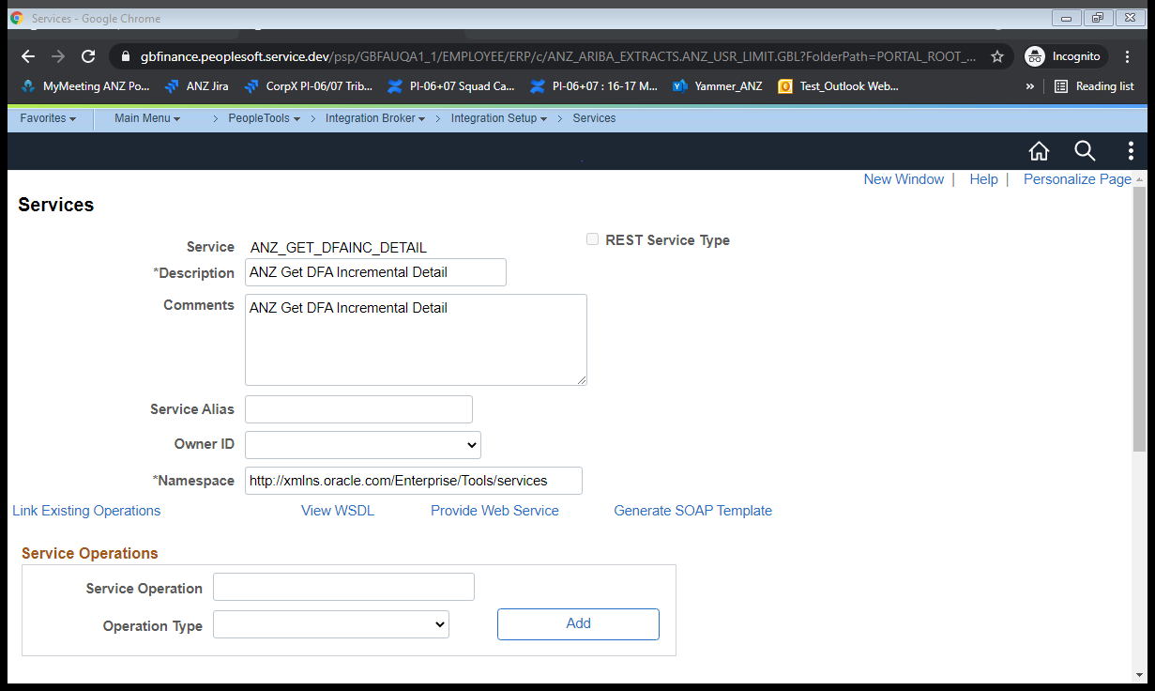

Click on View WSDL link

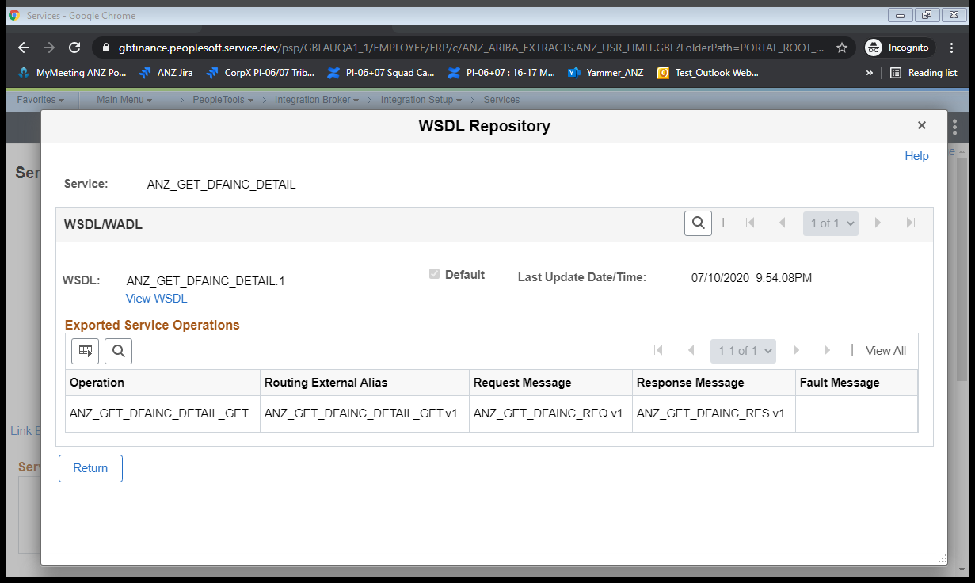

Click on View WSDL link

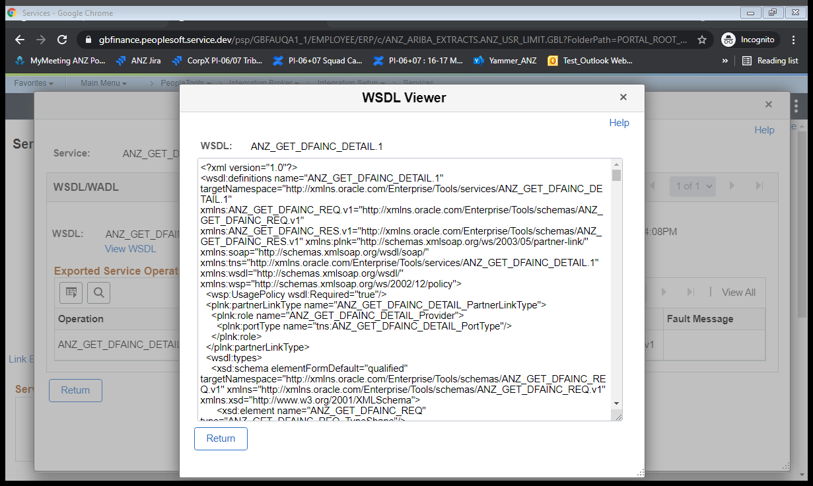

Copy the WSDL completely and save it as an .wsdl extension file as shown below:



Try loading the wsdl file in the soapUI with a project(DFA) created as shown below

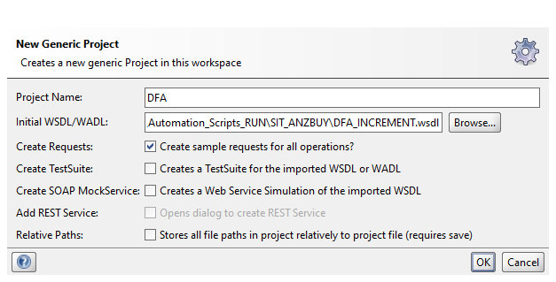

Click on OK Button and update the "from date” and “to date” as below

Click on “Auth” and enter the credentials and select the New authorization as shown below

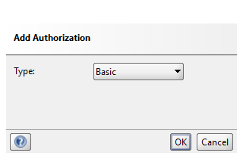

Click on OK Button

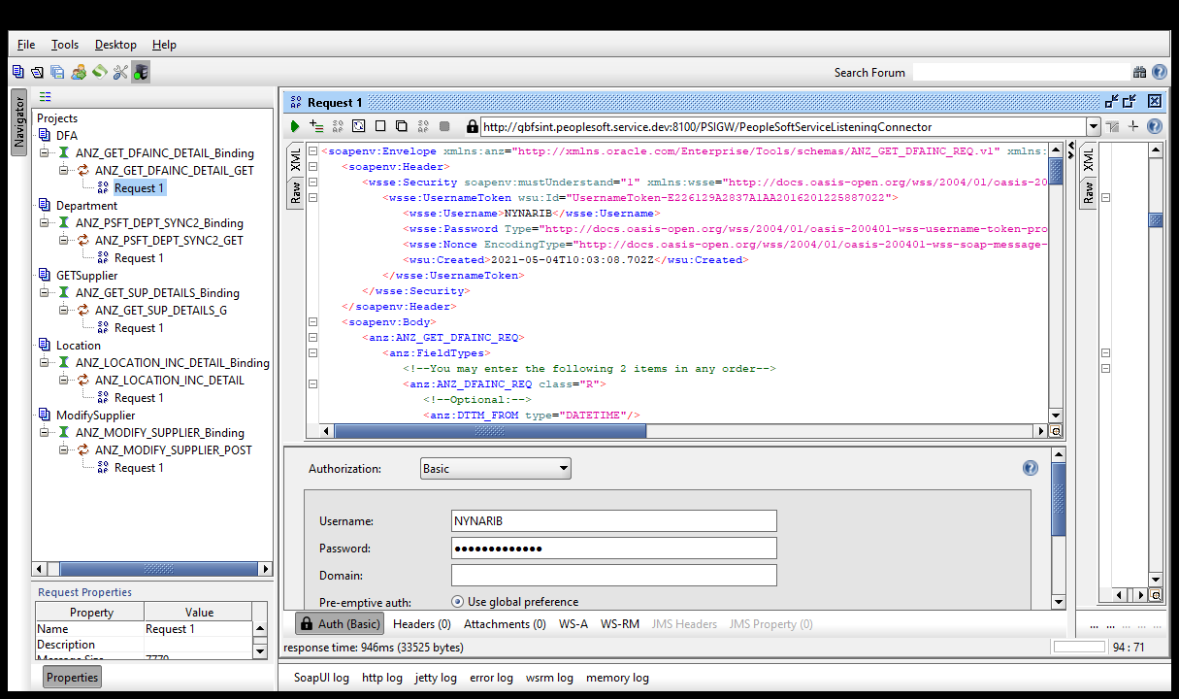

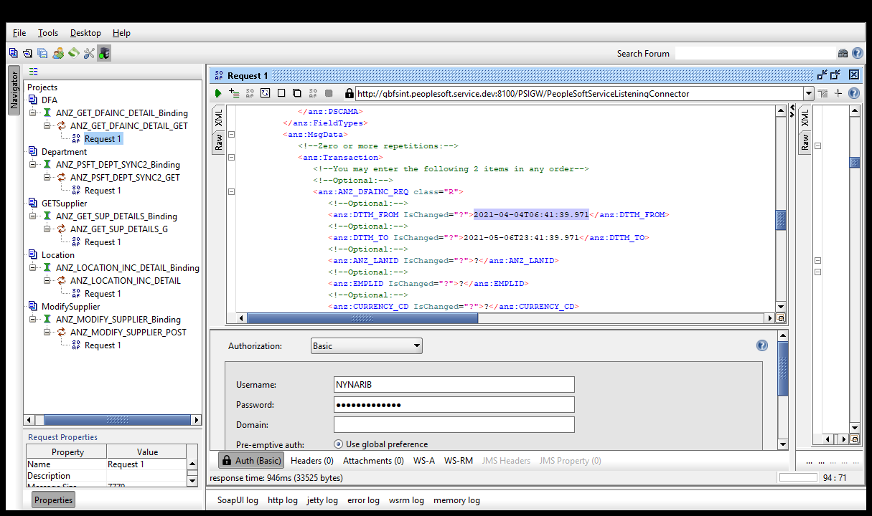

Right Click on the request tab and Click on “Add WSS Username Token” and select it as “PasswordText” as below

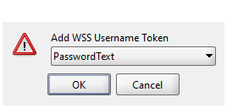

Click on “Submit request to specified endpoint URL”

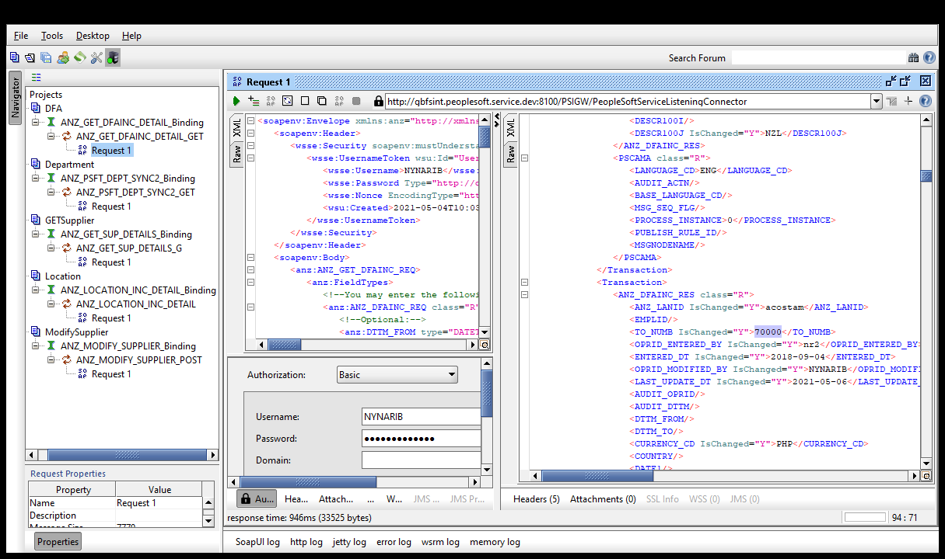

Verify the Response with the updated details as above